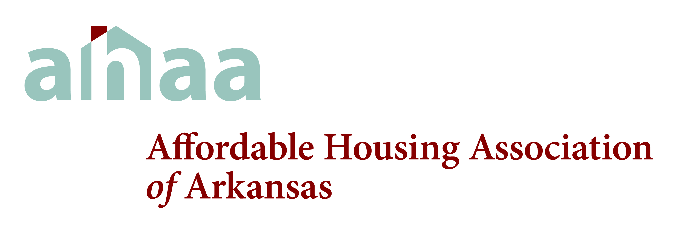
P.O. BOX 1358
SILOAM SPRINGS, AR 72761
PHONE: 479-524-7791 FAX: 479-549-3820

This lease is NOT intended for and is NOT appropriate for HUD properties and do NOT have HUD approval.

LEASE AGREEMENT ORDER FORM

This 3-part precarboned renter lease agreement is consistent with all current federal and state housing and law and Rural Development (formerly FmHA) regulations and procedures. AHAA makes the lease available to its members only.

Please send renter lease agreement forms to:

Name:__________________________________________________________________

Company:_______________________________________________________________

Mailing Address:__________________________________________________________

City:_________________________State:_______Zip:____________________________

Telephone:_______________________________________________________________

The minimum order is one package of 50 three part leases.

Number of packages ordered________________ x $50.00 each = ___________________

Make check payable to AHAA

FOR OFFICE USE
Date Received______________________ Check Number _________________________

Date Mailed______________________________________________________________

